**CITI 2.0 Manual Guide**

OVERVIEW

This CMS system is the background management system of the CITI 2.0 project, which can query, change, delete, and increase the data in the database. And there are some apis, these APIs are used to let the front-end page get and change the data in the database, the data is kept in sync.

Logging in

You need to log in before using. There is a login button on the home page of this system, you can click this button to go to the login page.

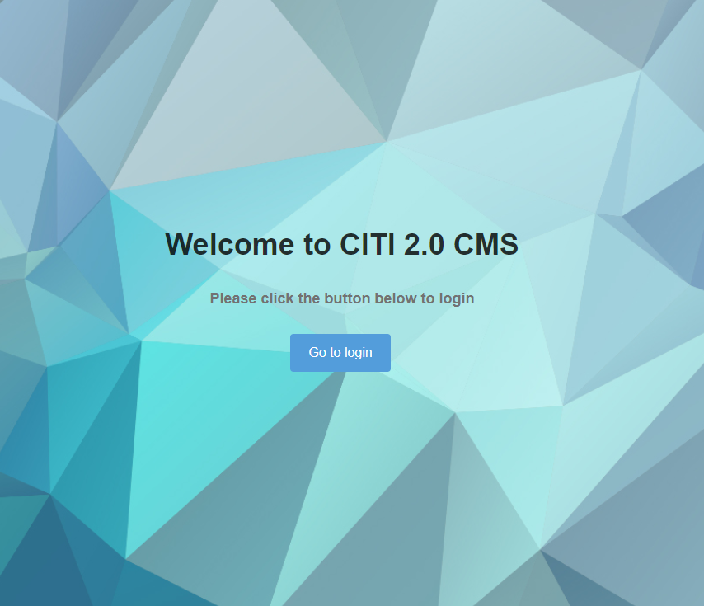

After logging in with your username and password, your username will be displayed on the page at the top of the page:



You can click here to select “Edit account information” or “log out” in the pop-up drop-down list, of course you can also perform these operations in the account options.

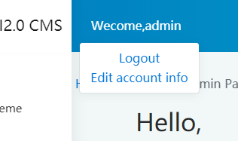 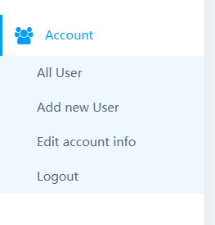

Query all data

Click on the content you want to query, and then a drop-down list will appear, where you can select all data options, using Visit as an example:

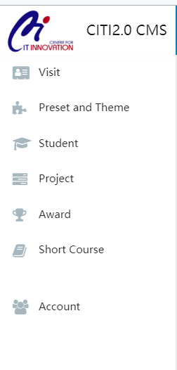 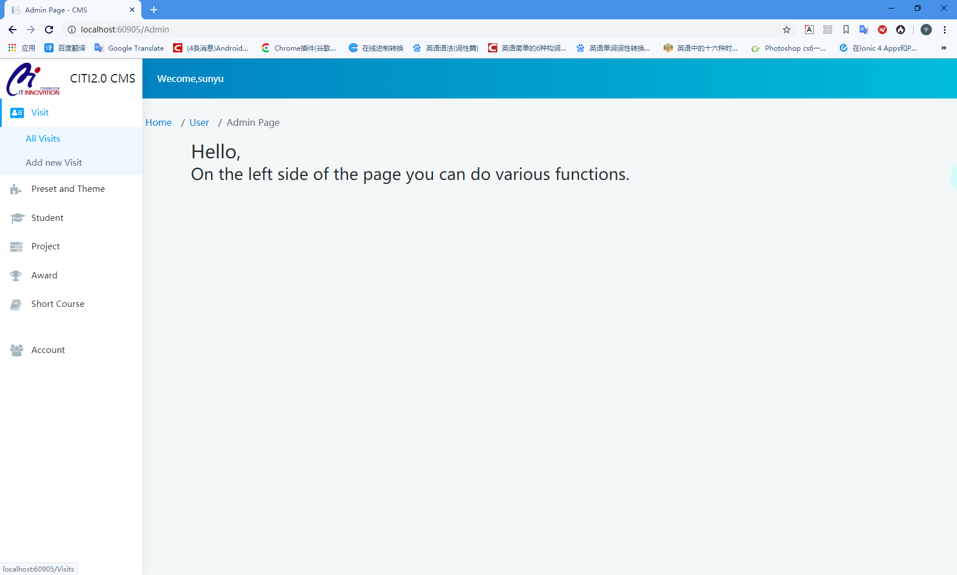

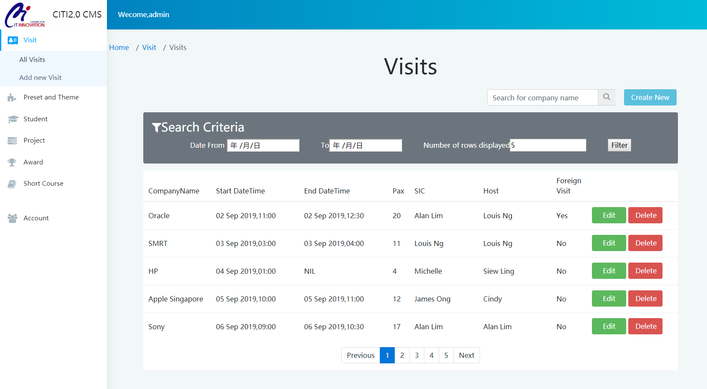

You can filter by selecting the start time and end time of the filter and the number of lines displayed per page in "Search Criteria".

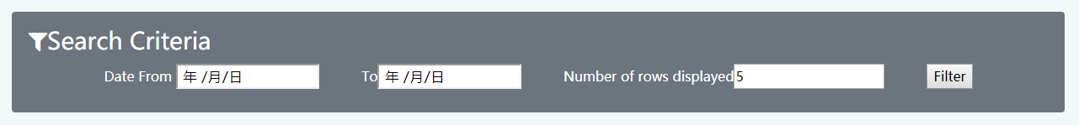

You can also search for the company name in the search box to view the company's access history.



Edit data

You can edit the data by clicking the "Edit" button after each line of data.



The edit information page is as follows, you can edit the information here, then click the "save" button below to save. If you don't want to save, you can leave this page directly or click the "Back to list" button to return to the full data interface.

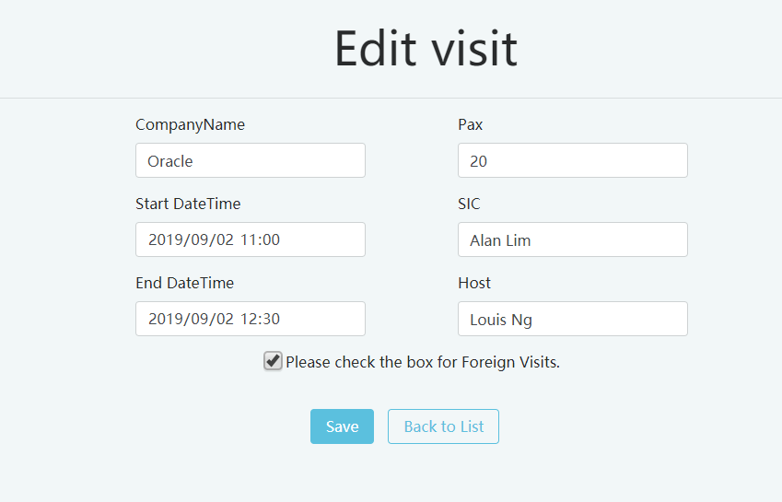

Delete data

Delete data is similar to edit data. You can click the delete button next to the edit button. It will jump to an information confirmation interface. In this interface, you can check the information and click the delete button to delete it.

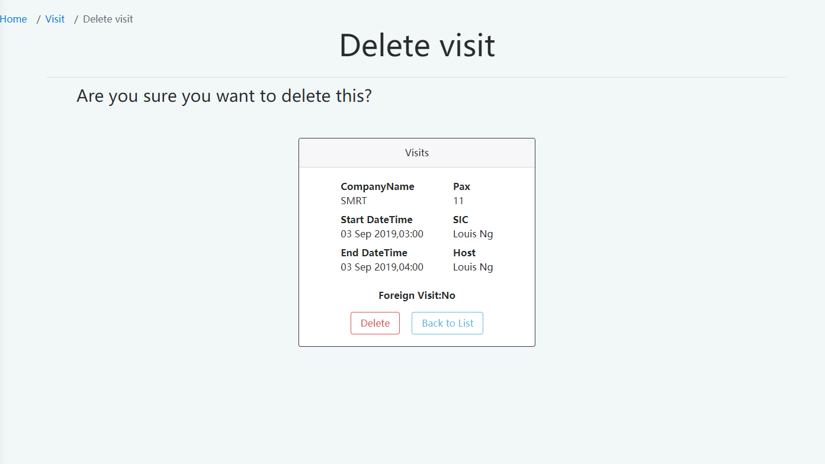

Create data

You can create data by clicking on "Add new Visit" in the menu bar or by clicking the "Create new" button in the full data interface.

 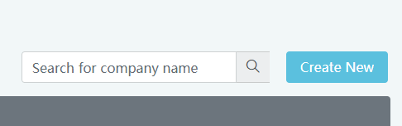

Create a data interface as follows, Visit has two ways to add data, one is to upload an Excel file upload and the other is to fill in the information upload. But most only can create data by filling in the information.

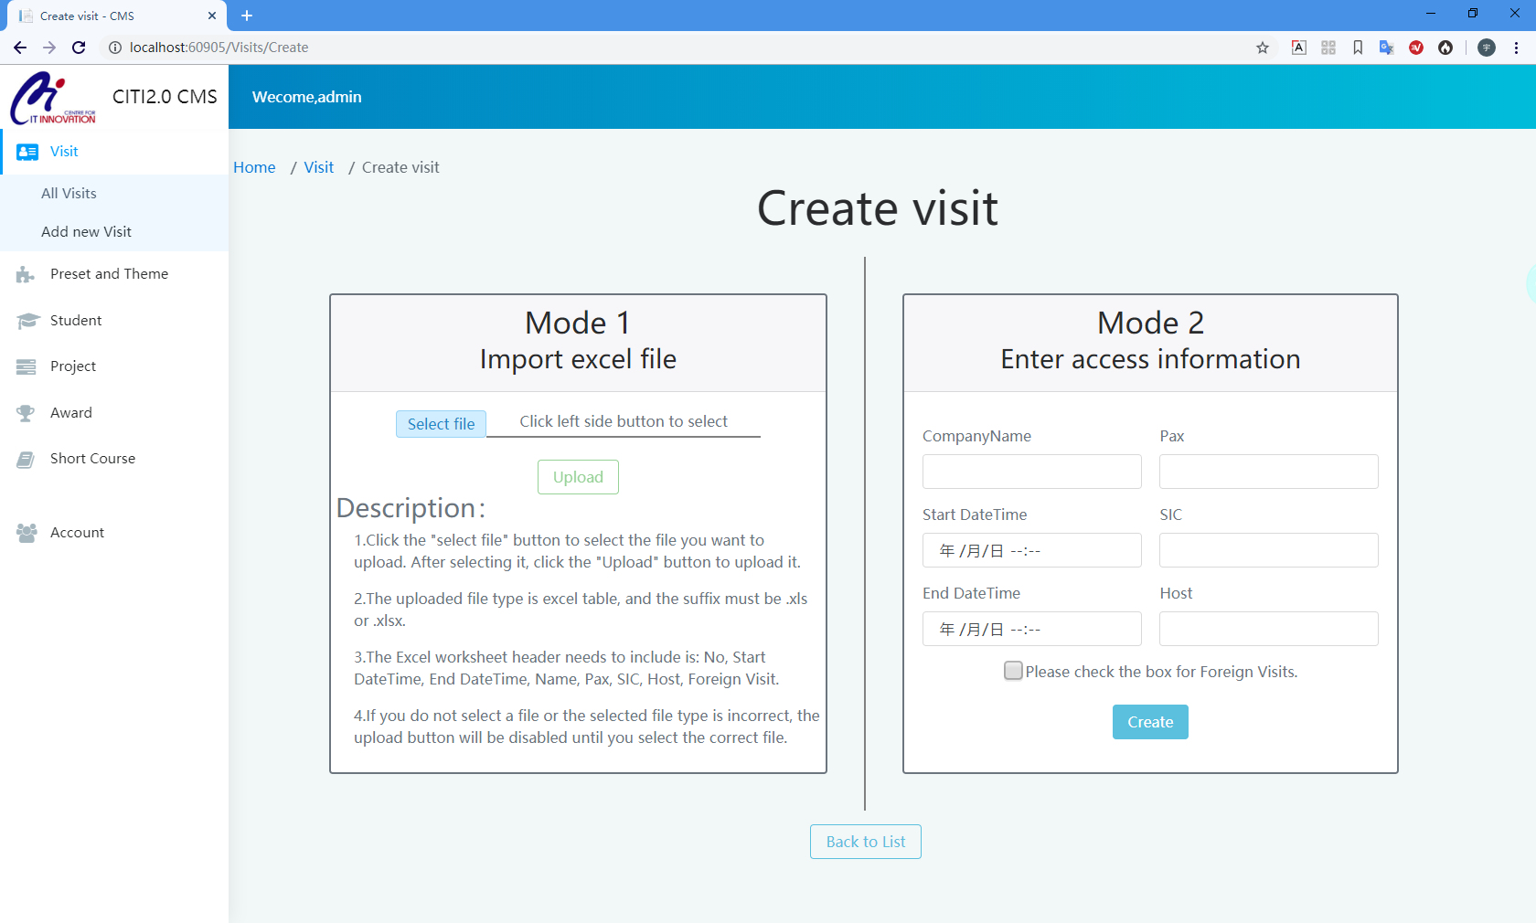

Add data by file upload method will add all the data in the file and judge which data already exists. Which data needs to be updated, which data needs to be added, and which data may need to be deleted. Some of the requirements for the file are already displayed on the web page, you can read this.

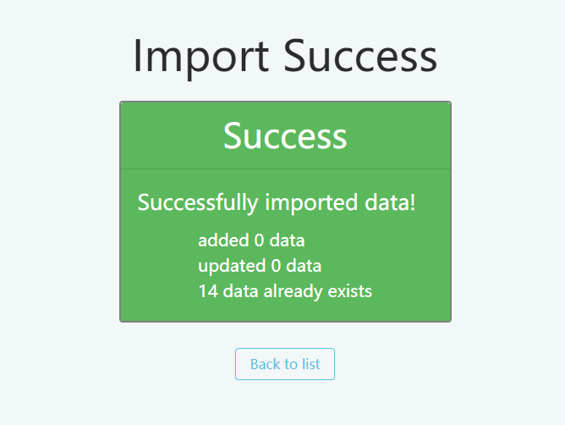 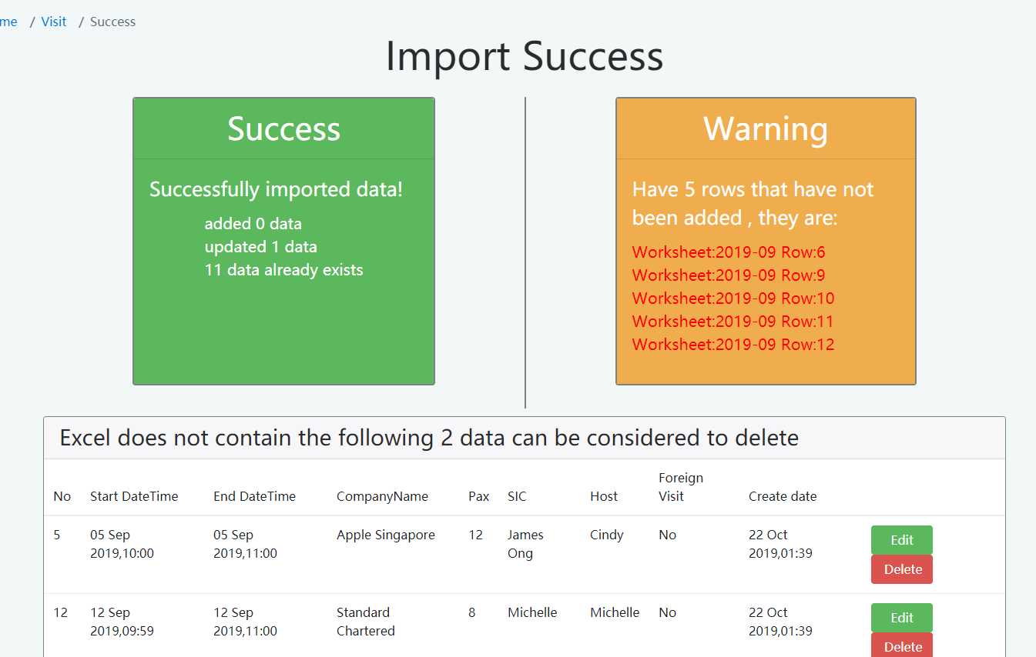

The operation of other modules is very similar, you can refer to the above example to complete all operations.